Exercise: Java: Unit testing

Write the unit tests for following:

* OrderService.java

Answer:

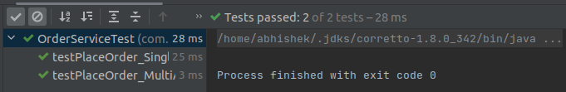

* EmailService.java

Answer:

